**STUDENT PROJECT TRACKING THROUGH WEB BASED APPLICATION**

**ABSTRACT**

As the college in offline accessibility software, **“STUDENT PROJECT TRACKING THROUGH WEB BASED APPLICATION”** has helped staff to track and view student accessibility policies and practices, and leverage the best in accessibility in marks by this web-based application. In today’s college days with tight deadlines and overloaded work of staff, college organizations often need more than just a web product. The staff can easily find out the project status of each student with the help of our system.

With that in mind, staffs are now pleased to enter the Students project details through the offline software in one hand to enter and track their details. In same way it leads to very easy empowerment of software accessing one by the single staff to track the details very clearly, for this problem we need to track the students efficiently in such a way we have designed the Web based application to track it. The information about student project and their details can be generated as a report through the report option. To know the overall details the maintained information are extracted as report for any use.

The system has introduced for keeping the students project details in tracking manner, now the project has modules such as student’s entry, staff allocation to students as guide, project status tracking of students, at currently student has got how many marks, how many days absent to the review, title submission, guides reports are all view by online and allocation of project also done by online, with corrections, modifications etc.

**SYSTEM SPECIFICATION**

**HARDWARE SPECFICATION**

* Processor : P 4 700 GHz.
* RAM : 4 GB RAM
* Hard Disk Drive : 180 GB

**SOFTWARE SPECIFICATION**

* Operating System : Windows 7/8/10
* Front End : JAVA
* Back End : SQL

**MODULES**

1. **Admin Login**

This module admin can able login into the application and perform an action to managing the student project tracking. Admin can have all the access to do the bellowed modules activities.

1. **Student Registration Form**

This module admin collects the all the information from the student and stored into the student table. Student table have all the requested field to map the application. Once the student has a mapped before should create the registration form.

1. **Create Project Details and Requirement**

First admin should register the project details and requirement. After then they can able to check the requirement, based on the requirement mean to allocate the student to particular project.

1. **Project Allocation**

Admin compare the technology wise student to allocate the student to the particular project. Once all the students are allocating into the particular project their list will be showing into the project status window.

1. **Student Details**

Here we can able view the all the student details and allocating project details as well. A cumulative report can we collect here for the user. We can check the student count and student project details.

1. **Pending & completed project status**

This module will show the user for displaying the pending and completed project details. Admin can easily check the current status of the all the project in a single window.

**Data Flow Diagram / USE Case Diagram**

**LEVEL 0**

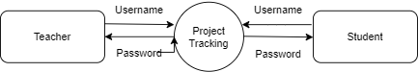

**Level 1**

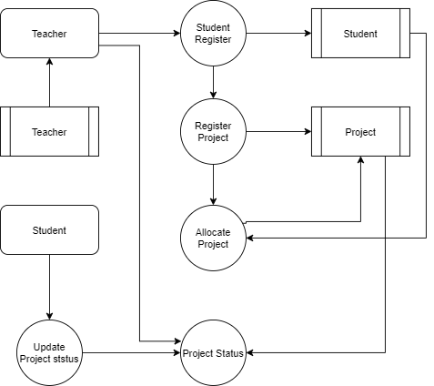

**ER Diagram**

